NORLOG
INSTRUCTIONS LARGE TREE SEAT
PLEASE READ BEFORE YOU START BUILD.
CONTENTS
24 WHOLE LOGS
3 HALF LOGS
3 SEATS + 6 SCREWS

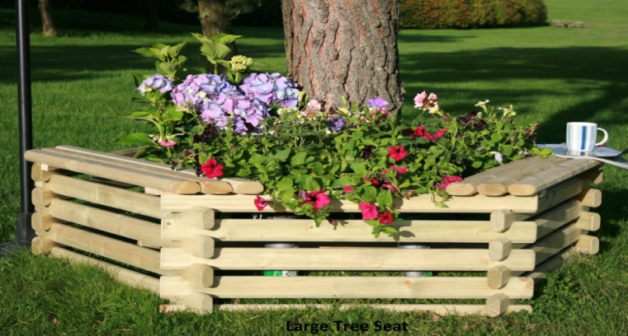
- START WITH THE 3 HALF LOGS AROUND BASE OF YOUR TREE. fig1.
- CONTINUE BUILD WITH WHOLE LOGS 3 PER ROW, PLACE ONE SIDE OF THE LOG TOGETHER FIRST THEN OFFER THE OTHER SIDE, CHECK TOP AND BOTTOM CUT OUTS ARE IN LINE, GENTLY TAP THE LOG ONE WAY OR THE OTHER TO GET THEM IN LINE BEFORE JOINING THE TOP AND BOTTOM LOGS. A RUBBER HAMMER OR WOOD MALLET IS THE BEST TOOL TO USE. fig2.
- WHEN ALL 24 LOGS ARE USED, POSITION AND SCREW THE 3 SEATS IN PLACE. (top log to top log) fig3.

fig1 fig2 fig3
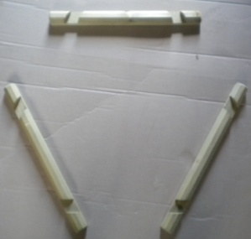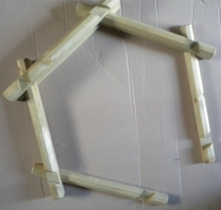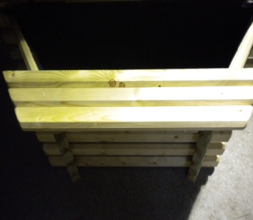
NORLOG UK Ltd. Unit 9N. Site A. Rednal Ind Est. Rednal. Oswestry. Shropshire. SY11 4HS.
Tel/Fax: 01691 610000. Email: info@norlog-group.co.uk
www.norlog-group.co.uk

