NORLOG
TOP OF REGENT TREE SEAT INSTRUCTIONS.
PLEASE READ BEFORE YOU START YOUR BUILD.
CONTENTS
12 Whole Logs
3 Packs Reducing Logs
3 Half Top Logs
Fixing Pack

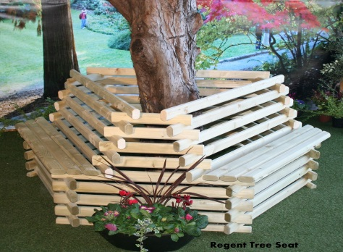

Please note this is a natural wood product and some components will absorb more colour than others, they will all blend together after a few weeks.
Once you have completed assembling the lower section of your seat, continue your build.
- Offer 3 of the whole logs parallel to the seat parts (fig 1), notch numbers upward facing, running in a clockwise direction do not screw this row down yet. (fig 2).
- Offer the 3 longest of the reducing logs (small logs) to the whole logs that are running parallel with the seats, notch numbers upward facing (fig 3).
- Make sure the top and bottom cut-outs are in line before interlocking them into each other. Tap one way or the other to line them up if you need too. (Screw each row together.)
- Continue this until all whole and reducing logs are used.
- Now finish with the three half logs notch number facing each other, fix the three half logs with the wire nails supplied. (pictures show whole logs to finish, this is now a half log to stop the top log rolling)
- You may wish to screw the top and bottom sections of your tree seat together using the six long screws provided. Fix through the first whole log you placed on to the lower seat part (fig1) please drill a pilot hole. This is your option, as they will stay together without the screws.

Now please enjoy your seat.

fig1 fig2 fig3 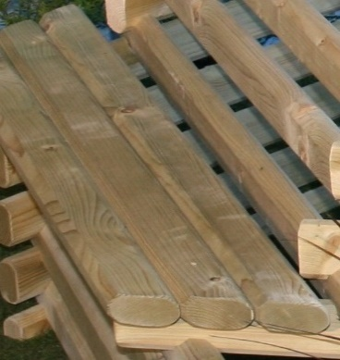 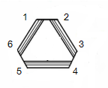 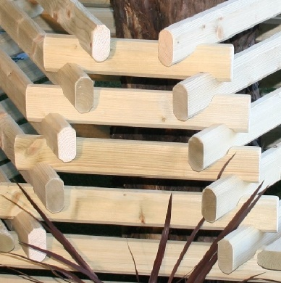
NORLOG UK Ltd. Unit 9N. Site A. Rednal Ind Est. Rednal. Oswestry. Shropshire.
www.norloguk.com

