NORLOG
INSTRUCTIONS 600 GALLON POOL
PLEASE READ BEFORE YOU START BUILD.
CONTENTS
48 WHOLE LOGS
3 HALF LOGS
3 SEATS + 6 SCREWS
1 LINER + liner protection
3 TIMBER BATTENS+PINS

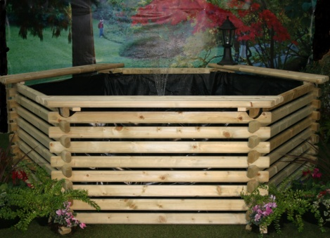
MAKE SURE THERE ARE NO SHARP OBJECTS UNDER THE LINER AS THIS WILL CAUSE A PUNCTURE.
- VERY IMPORTANT DO NOT EXCEED THE WIDTH AND DEPTH MEASUREMENTS!!!!!!!
- DIG OUT THE SUMP TO MEASUREMENTS OF LINER PICTURE. (DO NOT EXCEED MEASUREMENTS)
- LINE HOLE AND FLOOR AREA WITH 20-40 mm OF SAND.
- START WITH 3 HALF LOGS. fig1.
- CONTINUE BUILD WITH WHOLE LOGS 3 PER ROW, PLACE ONE SIDE OF THE LOGS TOGETHER FIRST THEN OFFER THE OTHER SIDE, CHECK TOP AND BOTTOM CUT OUTS ARE IN LINE, GENTLY TAP THE LOG ONE WAY OR THE OTHER TO GET THEM IN LINE BEFORE JOINING THE TOP AND BOTTOM LOGS. A RUBBER HAMMER OR WOOD MALLET IS THE BEST TOOL TO USE. fig2.
- WHEN ALL 48 LOGS ARE FIXED, PLACE LAYER OF LINER PROTECTION IN THE SUMP HOLE AND ON FLAT FLOOR AREA
- PLACE SHAPED LINER INSIDE AND SPREAD IT OUT MATCHING FRAME AND HOLE SHAPE, HOOK LINER LOOPS OVER TOP 2 LOGS. fig3.
- FILL WITH WATER. THE 3 BATTENS AND PINS ARE TO HOLD LINER IN PLACE ONLY DO THIS WHEN THE POOL IS FULL. (fix to 3 top logs)
- SCREW THE SEATS IN PLACE TOP LOG TO A TOP LOG. (not on one log) fig4

fig1 fig2 fig3 fig4
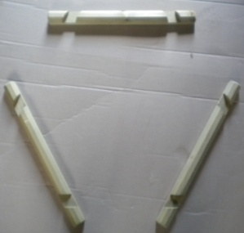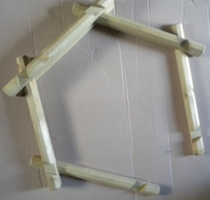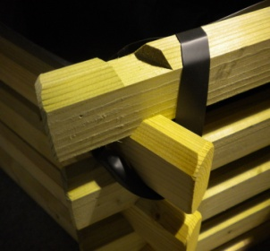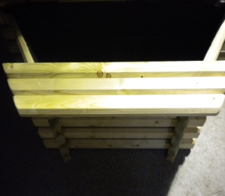
Norlog. Unit 9N Rednal Industrial Estate Queens Head Oswestry Shropshire SY11 4HS
Tel/Fax: 01691 610000. Email: info@norlog-group.co.uk

